Research document

Name: Tony Jiang

Date: 13 Sep 2023

Semester: 5

Project: Video call system

Contents

1. Introduction 4

2. Research questions 4

3. Sub-questions result 5

3.1. How should the video call facility work in the PRAS system? 5

First Idea 6

Second Idea 9

3.2. Which video call systems are there? 12

Zoom (Tested) 13

WhatsApp Messenger (Still testing) 13

WhatsApp Business (Some are tested, and some are Information online) 14

Skype (Tested) 15

Microsoft teams (Tested) 15

Jitsi Meet (Tested) 16

Talky.io (Tested) 16

JumpChat (Tested) 17

WebRoom (Tested) 18

Google meet (Tested) 18

Vonage meeting API (Information online) 19

WhatsApp Business API (Information online) 19

MirrorFly Video Call API (Information online) 20

Cometchat Video Call API (Information online) 21

Twilio Video Call API (Information online) 21

QuickBlox Video Call API (Information online) 22

Agora Video Call API (Information online) 23

EnableX Video Call API (Information online) 23

Sendbird Video Call API (Information online) 23

3.3. Which video call system can be implemented based on the requirements? 24

3.4. Which video call system benefits a better user experience? 24

4. Conclusion to the main questions 24

References 24

# Introduction

The purpose of this document is to conduct research to address the problem within the project, specifically, finding a solution for the video call system. To tackle this problem, I will formulate a primary research question and several related sub-questions. These sub-questions can be explored through interviews, internet research, prototyping, and other methods.

The challenge in this project revolves around developing a video call system within the PRAS system. This document will provide a detailed account of the steps taken to address each sub-question and the overall problem-solving process.

# Research questions

**Main question:**

**What possible solutions are there, to create a video call facility to implement in the PRAS system?**

**Sub-questions:**

The strategy and methodology for the FHICT can be found at this link: <https://ictresearchmethods.nl/Methods> and <https://cmdmethods.nl/> .

1. **How should the video call facility work in the PRAS system?**

* **Strategy: Field**
* **Methods: Document analysis, interview**

1. **What video call systems are there?**

* **Strategy: Library, Workshop**
* **Methods: Available product analysis, Literature study, Brainstorm**

1. **Which video call system can be implemented based on the requirements?**

* **Strategy: Workshop, Stepping Stones**
* **Methods: IT architecture sketching, Prototyping, Requirements list**

1. **Which video call system benefits a better user experience?**

* **Strategy: Lab, Stepping Stones**
* **Methods: Usability test, Unit test, Persona**

# Sub-questions result

## How should the video call facility work in the PRAS system?

Currently the video call occurs on a tablet using WhatsApp. Normally the SVb employees would check the daily agenda to determine if there are any appointments scheduled. If there are, they have to look at what type of appointment it is and with whom. They have to first double click on the appointment box to see all the information of the appointment. See figure 2. Due to sensitive information, I have made a wireframe and dummy data of the user interface.

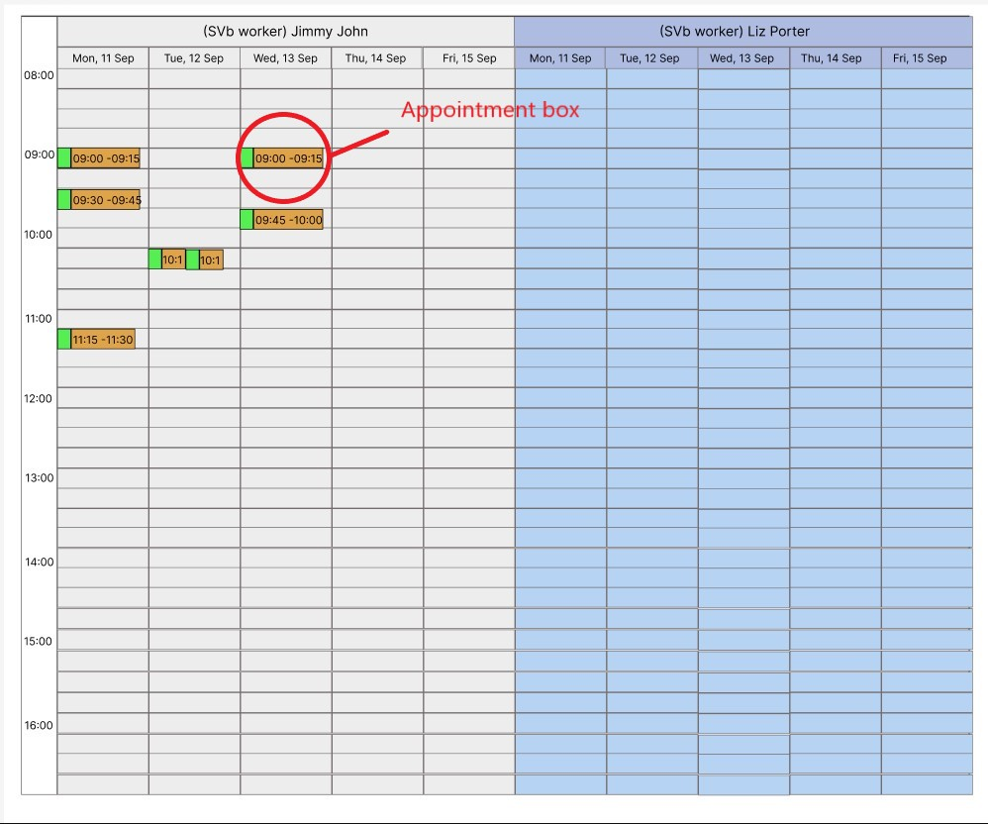

Figure : Overview of the agenda.

Figure : Information of the appointment.

After looking at the information the SVb employee would use the company tablet to contact the retirees on WhatsApp video call. They would need to have the retiree’s information saved in order to make a WhatsApp video call.

SVb now wants to eliminate the process of using a tablet to make video calls. They want video calls to be made through the PRAS application, which serves as the central hub for managing all pension client information. There are two concepts/ ideas to address this problem. The concepts can be found in the **Concept Document**. For the full, detailed process, please refer to the “**Wireframe**” document. Here is a summarized process for both ideas.

### First Idea

The first idea is to add a “Start Video Call” button to the appointment box. Clicking this button will initiate a video call with the retiree through WhatsApp. A video call interface will appear when the button is clicked, allowing the SVb employee to contact the retiree. After the video call, the SVb employee can end the call using the video call interface, and it will log the start and end times of the call, as well as the date. Figures 3 to 7 depict the process of initiating and ending the video call with the retiree.

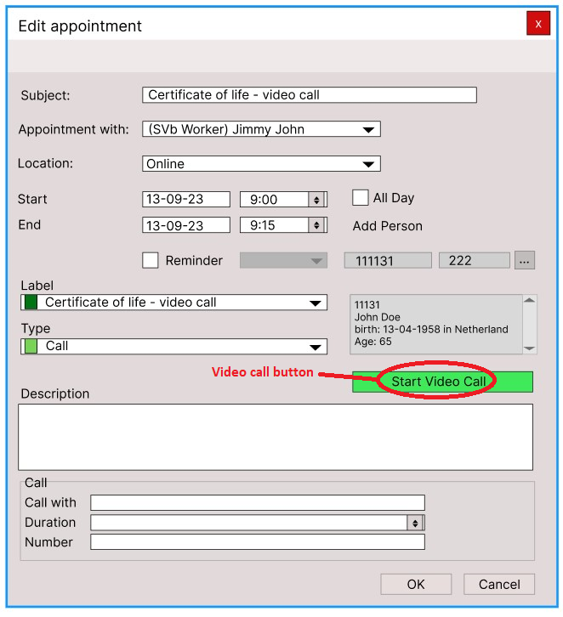

Figure : “Start Video Call” button for the first idea.

Figure : Connecting to retiree's phone.

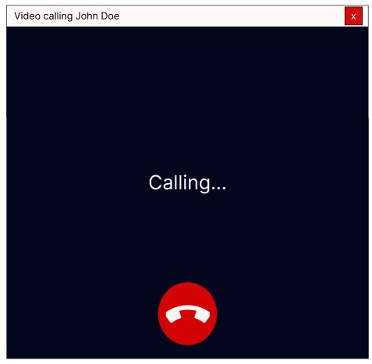

Figure : Connected to the retiree.

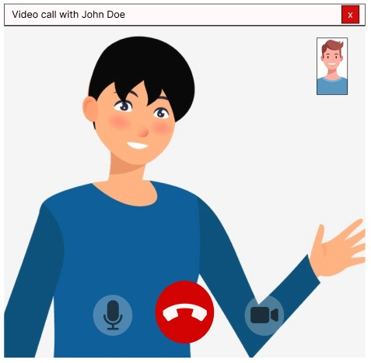

Figure : In a video call with the retiree.

Figure : End video call.

### Second Idea

The second idea, in the initial part, is the same as the first idea: adding a “Start Video Call” button to the appointment box. After clicking the “Start Video Call” button, the video call interface will display and place the SVb employee into a video call meeting. The SVb employee has to admit the retiree into the call when they join the meeting. The retiree can join the call through a link sent by email, SMS, or WhatsApp. After the meeting is finished, the SVb employee can end the call, and the system will log the start and end. times of the call. Figures 8 to 12 depict how the video call process should work.



Figure : "Start Video Call" button for the second idea.

Figure : Joining the meeting.

Figure : SVb employee joined the meeting.

Figure : Retiree joined the meeting.

Figure : End video call meeting.

## Which video call systems are there?

There are all sorts of video call systems, it depends on what type of video call system you want. There are free versions of the video call systems and there are paid versions of it. I won’t go through all of them, but I will mention some of them based on what I saw on the internet, or have tested out, or have used them before. I’ll also provide the type of features they offer. Please note that there might be some missing information that I couldn’t find.

#### Acronyms

In here we will give the full name of the acronyms/ abbreviations and describe what it is and what it does. This is mostly use as reference for the video call systems if they have these acronyms.

**SDK:**

SDK stands for software development kit. Also known as devkit, the SDK is a set of software-building tools for specific platform, including complier, code samples, documentation, debuggers and, often a framework or group of code libraries such as set of routines specific to an operating system (OS).

**WebRTC:**

WebRTC is real-time communication for web. It supports video, voice and generic data to be sent between peers, allowing developers to build powerful voice- and video-communication solutions.

**API:**

API stands for Application Programming Interface. It’s a way for two or more computer programs to communicate with each other. Application refers to any software with distinct function. Interface is like contract of service between two applications. This contract defines how the two communicate with each other through requests and responses.

**The free version of a video call system is:**

### Zoom (Tested)

* You can download the app, or you can use the browser-based video call on the desktop.
* You have to create an account to host the meeting.
* You have to download the zoom on your mobile phone to join the call.
* Can join the call through invite link.
* Host has to admit the guest to join.
* It gets a bit easy to use once you get used to host the call or be a guest of the call.
* Won’t let you join an old link.
* It has a chat box.
* You can use some of the features of Zoom API for free.
* For the free version the call is capped at 40 minute long.
* You schedule zoom meeting to calendar.
* You can add emoji reaction.
* You can make use of white board.
* You can add break rooms.

*To separate people and put them into other call.*

* You can show caption in the call.
* Can share screen.

### WhatsApp Messenger (Still testing)

* You can use the web version or desktop app.
* You need to download the app on mobile.
* You need to have a phone number to use this.
* You need to scan the QR-code on the web version and desktop app from the mobile app to use the web version or desktop app.
* You can’t make a video call on the web version.
* The web version stays active as long as you keep using the mobile app version.

*After 14 days of inactivity on the mobile app, it will log the user out of the web version.* (**Still testing**)

* You have to relog on the web and desktop app with your mobile app.
* WhatsApp account can be connected at max to 5 devices.
* Everyone has it.
* You can make a video call on the desktop app.
* Can message someone
* Can send voice notes.
* Can send videos.
* Can make phone calls.
* Can send files.
* End-to-end encryption for messages, photos, videos, voice messages, documents, status updates and calls.

*Encryption is to convert string of items like message and etc. into special code so that no one can read it. You need special key or password to decipher it.*

### WhatsApp Business (Some are tested, and some are Information online)

* This is kind of the same as the WhatsApp messenger but for small business.

*Has the same features from the WhatsApp messenger and addition features.*

* You need to have a phone number to use this. (**Tested**)
* You can transfer your data from WhatsApp Messenger to WhatsApp Business.
* Supposedly you can use the same web and desktop app as the WhatsApp Messenger. (**Need to test**)
* You can only log to 5 devices.
* You can add opening hours on your profile.
* You can add company website on your profile.
* You can add company address on your profile.
* You can add company email on your profile.
* You can send unlimited messages to your customers.
* Can broadcasts message up to 256 contacts.

*Customer must save you as contact to receive the broadcasts message.*

* Can send notification and promotional messages

*Notifications need to be approved by WhatsApp. Notifications are mostly alerts, no promotion of product.*

* You can add custom messages describing your business.
* Can do quick replies.

*They are customed messages for frequently asked questions.*

* Can make automatic greeting messages.

*For client initiating a conversation or 14 days of inactivity.*

* Can make away massages.

*To let the customer, know when you’re away or unavailable.*

* Can see message statistics

*Can see how many messages were send out, read, and delivered.*

* Can create catalogues

*Show case your products.*

* Can integrate with Facebook Shop.

*Link your Facebook Shop.*

(Hess, 11 October 2023) (Carter, 25 August 2023)

### Skype (Tested)

* You can use Skype without creating an account.
* On desktop you can use the browser or app.
* Invite to call with link.
* You need to download the app on mobile to use Skype.
* Easy to use and understandable.
* Can track how long the call is.
* Can join through an old invite link.
* There is a chat box.
* You can share your screen.
* You can record the call.
* You can call international phone number.

*You have to pay a flat fee.*

* You can raise and lower your hand.
* You can share files.
* You can change the background of the camera.
* You can use Skype API for free.

### Microsoft teams (Tested)

* You have to have an account to receive video calls and to make video calls.
* The video call can be scheduled or directly called.
* Can invite to video call meeting with link.
* You can join the call through link or meeting ID.
* You can join the call without an account, but you have to create a name.
* The scheduler has to admit people to the video call.
* More for organizing company and educational meetings.
* You have to download the app on mobile to use.
* On desktop you can use the browser or the app.
* There is a chat box
* You can create channels for group.
* You can record the call.
* You can lower and raise your hand.
* You can screen share.
* You can change your background.
* You can react to a message.

### Jitsi Meet (Tested)

* Has to have an account to make the video call.
* Need to name the room meeting.
* Room name needs to be unique.

*To prevent anyone from joining.*

* Track how long the call is going.
* Can join the call with or without inputting your name.
* Can invite through link.
* On desktop you can use the browser or the app.
* Mobile can join the call via browser or app.
* Guest can’t start the video call it has to be the one with an account.
* Can rejoin the video call through an old invite link.
* API free to use, depending on active monthly users.
* Can share screen.
* Can make use of chat box.
* You can schedule a meeting on google calendar.
* You can lock the meeting with a password.
* You can show a white board and write or draw on it.
* You can change the background of the video.
* You can create a poll to vote.
* You can record the call.
* You can start a live stream in the call.
* You can share your audio.

*Share the music or audio you listing to others.*

* You can raise/lower your hand for attention.
* You can toggle push to talk with space button (not on mobile).
* Mobile can add emoji reaction.
* Can adjust screen view.

### Talky.io (Tested)

* You don’t have to have an account to make the video call.
* You need to choose a unique name for the video call meeting.
* You can lock the room.

*To prevent strangers from joining the room, they need a code to join.*

* Phone can join through link with mobile browser.
* Interface of the browser version is a bit wonky on mobile.

*Everything on the interface is compact, on each component.*

* Everyone can kick each other from the video call.
* Max 6 people in call.
* Can join old invite link.
* You can play a mini game while waiting for people to join the call.

*If you are the only one in the call you can play the game, it’s similar to google web browser when you don’t have internet.*

* There is a chat option.
* You can toggle push to talk (not on mobile).
* You can share your screen.
* You can integrate their SimpleWebRTC to website.

*It’s their version of WebRTC. There is a free trail period. After that you have to pay monthly depends on the plans and pricing you choose.*

**\*NEED TO TEST ON THE IPHONE\***

### JumpChat (Tested)

* You don’t have to create an account.
* It auto generates a room code for you.
* It is browser based on desktop.
* You can use the browser on the phone to video call, but it won’t work on iPhone.
* You have to click I’m ready to join the call.
* You can reuse the old invite link.
* Anyone that knows the room code, can join.
* There is an app version on mobile.
* The video on the phone is wonky.

*Sometimes the video of the other person in the call is too big to fit the screen or it fit just right at the top. If you rotate the phone horizontally, it will be just right.*

* All communications are encrypted in the video call.
* No limits to the number of people, except for bandwidth.
* You can chat.
* You can share files.
* You can share screen.
* You can lock the room.
* You can admit the guest to join the call if the room is locked and the guest doesn’t know the code.
* JumpChat is built on top of WebRTC.

*You can find the definition for WebRTC in the* *acronyms* *section.*

**\*NEED TO TEST ON THE IPHONE\***

### WebRoom (Tested)

* You have to enter a name and an email address to start the video call.
* The email address can be a fake address.
* The email is just to log the session.
* You can keep trying the free session with the same email address.
* The free session is only 20 minutes long.
* The free session can hold up to 12 people in the call.
* You have to do a lot of checks before you join the call.

*Like microphone check etc.*

* Can’t use the old invite links.
* Tracks how many minutes you have left before the session ends.
* The guest also has to provide a name and an email address to join the call.
* The guest can’t have the same email address as the invitees.
* Can file share.
* Can share screen.
* There is an interactive white board.
* There is a chat box.
* Can create polls.
* It has notes that you can write on.
* You can switch screen view.

### Google meet (Tested)

* You need to make an account or logged in before starting a meeting.
* Can join through a link invite.
* Can join with the code provided by the host of the meeting.
* The code is created when the host start the meeting.
* The guest needs to provide a name before entering the meeting.
* You have to download the app on the phone.
* Android user have Google meet pre-installed.
* Before joining the host must admit the guest first, when joining the meeting.
* You can schedule a google meeting on google calendar.
* You can add emoji reaction.
* You can share screen.
* You can change the background of your camera.
* You can raise and lower your hand.
* There is a chat box.
* You can make use of a build in white board.
* The guest can rejoin the call.

*They only have 60 seconds to rejoin.*

* Google API is free to use.

**The paid version of a video call system is:**

### Vonage meeting API (Information online)

* You can try a free trial version.
* Offers guild on building the API.
* You can integrate the API into your app.
* It can be created on the web, windows, android, macOS, iOS(Obj-C), iOS(Swift) and Linux.
* It is hosted on the Vonage Video API cloud.
* Support all video use-cases

*1 on 1 video, group video chat or large-scale broadcast sessions.*

* It has audio and video recording.
* It has messaging
* It has built in WebRTC.

*You can find the definition for WebRTC in the* *acronyms* *section.*

* Can screen share.
* The pricing plans for video API start at $9.99 per month (plus taxes & fees applicable) with 2000 minutes.

*The pricing can be found* [*here*](https://www.vonage.com/communications-apis/video/pricing/)*.*

### WhatsApp Business API (Information online)

* Doesn’t have an interface and app.
* This is for medium to larger companies or large enterprise.
* You need to have a phone number.
* It has the same features as WhatsApp Business but with additional features.
* Can manage thousands of customer interactions with your team.
* You need to follow a certain business terms and conditions before applying for the API.
* You can sign up for Facebook Business Manager to get approved to use the API.

*Need to provide acceptable document to get approved on the business name and business address, which you can look at how the process is* [*here*](https://yellow.ai/blog/whatsapp-business-api/#:~:text=1.%20Apply%20for%20WhatsApp%20Business%20API)*. After that you can start on the labor-intensive programming.*

* You can apply for WhatsApp solution providers or WhatsApp partners to get access to API.

*They are third-part company that help you get access to WhatsApp API. They are approved by WhatsApp and can help and guide you in integrate the API or provide an already build application for you.*

* There is an on-premises API and cloud API.

*On-premises API are hosted on your own server or WhatsApp solution providers. Cloud API are hosted on Meta’s cloud server. Cloud API is very new currently.*

* You can add multiple devices.
* Can get verified badge.

*Gives the account credibility.*

* Charge per conversation.

*Must pay a fee if initiate a conversation***.** *Not per individual message. Conversations are 24-hour message threads between you and your customer. There are criteria to the conversation, and you can find it* [*here*](https://developers.facebook.com/docs/whatsapp/pricing#pricing-rules)*.*

* Customers need to initiate the conversation before you can start messaging them.
* Can integrate various customer relationship management (CRM) systems.

*CRM system is a tool designed for efficiently managing relationships with your customers. It stores and organizes valuable information about customer interactions and helps enhance communication between your business and each customer.*

*One of its key features is automating communication messages, particularly in customer support scenarios. It's often impossible to respond to all the customers instantly, and this is where a CRM system comes into play. It enables you to be efficient and automate communication tasks, ensuring that no customer query or request falls through the cracks. With CRM, you can provide more personalized and timely responses, improving the overall customer experience.*

(Gupta, 16 September 2023) (AiSensy, 08 August 2023)

### MirrorFly Video Call API (Information online)

* They have pre-built UI kit.
* Unlimited video calls.
* Can upload large file sharing.
* Can video recording.
* Add video calls on any platform or any device.
* It’s easy to integrate into app.
* Can do 1 on 1 video call or group call.
* Real-time call logs.
* Has flexible hosting.

*Can host on your own server or MirrorFly’s private cloud.*

* Can schedule a meeting.
* Can join via link.
* Easy to follow documentation.
* End-to end support.

*Easily get support on their experts’ anytime.*

* You can request a demo on it.
* There are 2 plans you can buy.
* Essentials (for 5k monthly active users): $399 per month.
* Premium (for 5k monthly active users): $999 per month.

*The price also depends on the monthly active users. 5k is the lowest option.* *Each plans have different features. The pricing can be found* [*here*](https://www.mirrorfly.com/pricing.php)*.*

* You can choose your preferred SDK platform to build the video calls on Android, iOS, JavaScript, React, Angular, or Flutter.

*You can find the meaning for SDK in the* *Acroyms* *section.*

### Cometchat Video Call API (Information online)

* There is a free trail option.
* Frameworks that they support: Android Java, Agular, Flutter, iOS, React, Android Kotlin, Laravel, PHP, React Native, Vue, and WordPress.
* Is able to share screen.
* Has interactive whiteboard.
* Share documentation.
* You can invite or direct dial.
* You can share screen.
* You can record the call.
* Easly integration.
* Pre-built UI kits.
* There is 3 plans pricing.
* Essentials (for 26 to 1000 monthly active users): $109 per month.
* Pro (for 26 to 1000 monthly active users): $509 per month.
* Custom: Need to contact them.

*The pricing is dependent on monthly active users and each plans have different features. You can find the more information about the pricing* [*here*](https://www.cometchat.com/pricing)*.*

### Twilio Video Call API (Information online)

* It has a free trail.
* It has a free version for one-on-one video call.
* It’s built on top of WebRTC.

*You can find the definition for WebRTC in the* *acronyms* *section.*

* It has documentation guide.
* Has one-on-one video interactions.
* Has peer-to-peer video interactions.
* Has group video interactions that support up to 50 participants.
* There is 4 plan pricing.
* For one-on-one: start for free.
* For peer-to-peer: $0.0015 per participant per minute.
* For group video call: $0.004 per participant per minute.
* High volume: custom, need to contact person.

*Each plans has different features. More information on the pricing can be found* [*here*](https://www.twilio.com/en-us/video/pricing)*.*

* It offers noise cancellation.
* It offers interactive whiteboards.
* It offers chat box.
* Offers tutorials and guides.
* The application it can be built on are: Node.js, Python, C#, Java, Apex PHP, Ruby and Twilio-CLI
* For the web-base it can be built on JavaScript SDK, Android SDK, and iOS SDK.

*You can find the meaning for SDK in the* *Acroyms* *section.*

### QuickBlox Video Call API (Information online)

* There is a free trail period.
* Built on WebRTC.

*You can find the definition for WebRTC in the* *acronyms* *section.*

* You can build a chat box.
* You can make use of voice calling.
* There is a push notification.
* You can make use of file sharing.
* Flexible data storage.
* Dedicated.
* On-premise.
* Own virtual cloud.
* You get support to help you if you have any problem.
* Easy and quick integration.
* Customizable UI Kits.
* It has documentation guide.
* It can be built on website, iOS, and Android.
* Can share screen.
* There are 5 plan prices.
* Basic: for free for 500 users that is registered in your app database.
* Starter: for $99 per month for 10,000 users.
* Growth: for $249 per month for 25,000 users.
* HIPAA Cloud: for $399 per month for 20.000 users.
* Enterprise: for $599 per month. Custom need to contact them.

*Each plans has different features. For more information on the pricing can be found* [*here*](https://quickblox.com/pricing/)*.*

### Agora Video Call API (Information online)

* Offers voice calling.
* Offers chat box.
* Offers Interactive whiteboard.
* Can record call.
* Can share screen.
* There is UI kit
* It offers in Android, iOS/macOS, Windows, Web, Electron, Flutter, React Native and Unity.
* Can add extensions.
* There is documentation guide.
* It offers app builder.
* Every month you get 10,000 minutes free.
* Price for video call starts at $3.99/1,000 minutes for HD video.
* Price for video call starts at $8.99/1,000 minutes for FULL HD Video.

*The pricing for both can be found* [*here*](https://www.agora.io/en/pricing/video-calling/)*.*

### EnableX Video Call API (Information online)

* You can try for free.
* Can build on any platform, browser, and coding language.
* There is UI kit.
* Can integrate 3rd party application.
* Can have 100 participants.
* Can add virtual background.
* Can add screen share.
* Can have live recording.
* You can monitor video call.
* The pricing is $0.004 per participant per minute (max 50 participants in a room).

[*Here*](https://www.enablex.io/cpaas/pricing/our-pricing) *you can find more information on the pricing.*

### Sendbird Video Call API (Information online)

* Direct video call.
* Group video call.
* It has call history.
* It has call muting.
* It can be built on iOS, Android, JavaScript, React native and Unity.
* It has call logs
* It has call recording.
* There is free trail.
* This is the 4 plan pricing:
* Developer: is free for max 100 monthly active users.
* Starter 5K: $399 per month for 5K monthly active users.
* Pro 5K: $599 per month for 5K monthly active users.
* Enterprise: custom pricing with millions of monthly active users.

*Each plans has different features.* [*Here*](https://sendbird.com/pricing) *you’ll find all the information about the pricing.*

* It has UI kit.
* It has share screen.
* It can share file and multimedia.

## Which video call system can be implemented based on the requirements?

The requirements that need to be adhered to are:

* Eliminate the use of table.
* Integrate the video call on the PRAS desktop.
* No special equipment or software required at the recipient’s end of the call.
* Log the start and end time of the call.
* Other to be determine.

The video call system must adhere to these requirements. I will categorize the video call systems into two sections. The first section is for systems that fulfill all the necessary requirements and will be labeled as “Compliant.” The second section is for systems that align with most of the criteria and will be labeled “Mostly Compliant.” I will also provide explanations for the reason why they are placed in the “Mostly Compliant” section.

### Compliant

### Mostly Compliant

WhatsApp Messenger:

It adheres to most of the requirements. The only thing that is missing is the ability to track the call log. Users can have WhatsApp on their desktop, and retirees don't need any special software or application. Since WhatsApp is their current video call platform, the integration with the PRAS app is designed to be seamless. When they click “Video call retiree's mobile phone number” (for detailed reference, see section 3.2.1 of the wireframe document), WhatsApp will open, and they'll be directed to the retiree's messenger page, where they can initiate the video call from the top right corner.

## Which video call system benefits a better user experience?

# Conclusion to the main questions

# References

AiSensy. (08 August 2023). *What is WhatsApp Business API: The Complete Guide (2023).* https://m.aisensy.com/blog/whatsapp-business-api-guide/.

Carter, R. (25 August 2023). *16 WhatsApp Business Features Worth Exploring.* https://www.uctoday.com/unified-communications/16-whatsapp-business-features-worth-exploring/.

Gupta, S. (16 September 2023). *WhatsApp Business API – Everything You Need To Know.* https://yellow.ai/blog/whatsapp-business-api/#:~:.

Hess, M. (11 October 2023). *WhatsApp Business app: What is it? Who uses it? What's best, app or API?* https://www.hello-charles.com/blog/whatsapp-business-app.